Obtain App Log For Debugging
2025-06-04
This document describes how to obtain app log information from a mobile phone device when an app craves for no explicit reason.
- Download tools
- Open a web browser and navigate to this page
https://developer.android.com/studio/releases/platform-tools
- Click an option of targeted OS
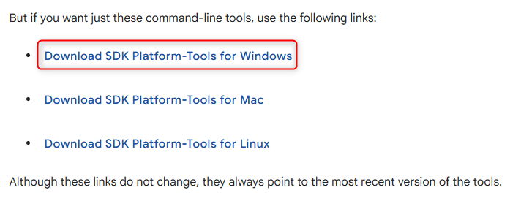
Fig 1. Select OS to download ADB tool
- Accept the license terms and click download
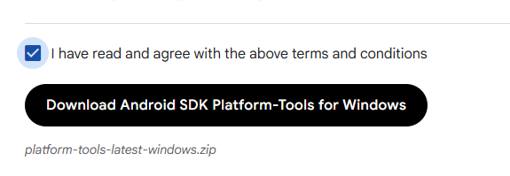
Fig 2. Accept terms and download
- Unzip the downloaded file(platform-tools-latest-windows.zip) and verify that adb.exe file exists, which is used for app logging.
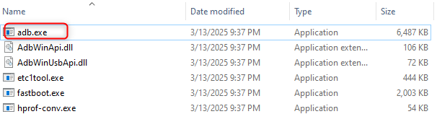
Fig 3. verify “adb.exe” file exists

- Enable USB Debugging
To get logs on your phone, we ask for two steps. The first is to enable "Developer Options" and the second is to enable "USB debugging." This section describes how to enable logs on Samsung Galaxy A23 5G. It should be similar on other types of phones.
- Enable Developer Options
- Open settings
Swipe up on the home screen and tap on the Settings app.
- Go to About Phone
Scroll down and tap "About phone"
- Open Software Information
Tap on "Software information"
- Tap Build Number 7 Times
- Find "Build number" in the list.
- Tap it 7 times quickly.
- You may be asked to enter your lock screen PIN or password.
- After that, you’ll see a message: "Developer mode has been turned on."
- Access Developer Options
- Go back to the main Settings screen.
- Scroll down — you'll now see "Developer options" near the bottom.
- Enable USB debugging
Once in Developer options:
- Scroll down to "USB debugging".
- Toggle it ON.
- Confirm the dialog that appears.
This is a reference video
https://www.youtube.com/watch?v=7FOAb8w0EgM
- Catch a log file from mobile app.
- Connect a mobile phone to computer which download an adb tool on by USB data cable.
- Go to the directory of adb.exe and open command prompt window on this directory. Type cmd in the path of file explorer like this.
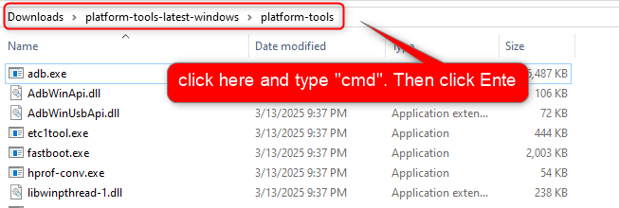
Fig 4. open “command prompt ” window on root of adb tool folder
- Check if device is connected to computer.
In command prompt, type the following command to check the connected device.
adb devices
The output should be following.
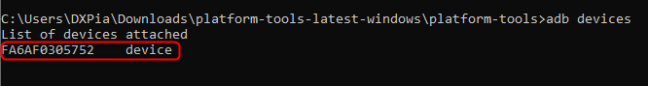
Fig 5. Check if mobile device is connected to computer.
If the device connected correctly, you can see the device ID like as Fig 5.
If you see multiple devices on it, please disconnect other devices to simplify the operation.
- Step by step to get the log why the app is crashed.
- Connect your phone via USB
- Make sure USB debugging is enabled (already done).
- On your PC, open a terminal and run:
adb logcat | findstr myandroid.app.hhobzic.inventorymobile > log.txt
- Let the app run. When it crashes, the log will contain crash details.
- Press Ctrl + C to stop logging. The crash details will be saved in log.txt in the same directory of tool.
- Just replace the above “adb logcat xxx”command by the following command. Then do the correct same operation to get another log.
adb logcat -b crash > log_crash.txt
This will save crash details into “log_crash.txt” in the same directory.
These 2 files(log.txt and log_crash.txt) is required for debugging.

